

Internship Report

*A report submitted in partial fulfillment of*

Integrated BTech in Computer Engineering

**Prepared by**

Tejas Maskar

**Under the Guidance of**

**Mrs. Farhadeeba I. Shaikh**

**Mr.Nishant Katiyar  
Mr.Roshan Kumar Vu**

[**BugendaiTech**]

**Integrated BTech in Computer Engineering**

**At**

**Department of**

**Polytechnic & Skill Development**

**Date of Submission**

**[ 25th July 25 ]**





An Internship Report Submitted to

***DR. VISHWANATH KARAD MIT WORLD PEACE UNIVERSITY***

Submitted by,

Tejas Maskar (1032230053)

Under the supervision of

**Mr. Nishant katiyar**

and

**Mrs. Farhadeeba I. Shaikh**

**Department of Polytechnic and Skill Development __________________________**

**Dr VK MIT World Peace University, Kothrud,Pune-411038**

**(Period from 5th June 2025 to 5th August 2025)**

***CERTIFICATE OF INTERNSHIP***





**CERTIFICATE**

This is to certify that the Internship Report entitled

Submitted by

**Tejas Maskar(1032230053)**

in partial fulfillment of requirement of an Internship at **BugendaiTech,** is a bonafide record of the work carried out by him/her during the period from 5/6/2025 to 5/8/2025. She has worked under the supervision of **Mr.Nishant Katiyar, Mr.Roshan Kumar Vu and Mrs Farhadeeba I. Shaikh.** She has fulfilled the requirement of the submission of the Internship report for Third Year Computer Science Engineering as per the syllabus prescribed by the MIT World Peace University, Pune.

|  |  |  |
| --- | --- | --- |
| **Mr. Sunil Giridha**r | **Mrs Farhadeeba I. Shaikh** | **Prof. J.G. Mante** |



**Vision**

To be an acclaimed school which facilitates to earn enriching knowledge, skills and lifelong learning in the streams of engineering to promote “culture of world peace.”

**Mission**

“To facilitate our students and the faculty with exposure and platform to contemporary practices to meet various challenges in ever advancing sectors of their field while using the gained knowledge for the welfare of human being.”

“To imbibe personal attributes and facilitate the students to pursue higher education and / or venture into entrepreneurship avenues by building competence to comprehend society/social needs.”

**Certificate of Completion**

This is to certify that Mr. Tejas Maskar *with PRN number 1032230053 of class* ***SYCO***has successfully completed **internship** work during the period of 5th June 2025 *to 5th August 2025 . The report is being submitted towards partial fulfillment of Integrated BTech program in Computer Engineering for academic year* ***2024-25****.*

***Internship Mentor Program Head Program Director***

*( Mrs.F.I.Shaikh ) ( Prof.J.G.Mante) (Prof.Dr.R. S. Kale)*

*Date – 25th July 2025*

*Place – Pune*

**Acknowledgements**

I would like to thank Mrs. Poonam Patil the HR of BugendaiTech for giving me the opportunity to do an internship within the organization.

I am also grateful to Program Director Prof. Dr. R. S. Kale and Program Head Prof. J. G. Mante for facilitating and supporting this internship program.

I am thankful to Mrs. Farhadeeba I. Shaikh for his/her continuous support & guidance during the internship period. I am thankful to Mr Nishant Katiyar for his timely help & guidance during the internship period

I am also thankful to all those from the BugendaiTech for making my working environment happy and rich.

Tejas Maskar

**Table of Contents**

|  |  |  |
| --- | --- | --- |
| **Ch. no** | **Topic Name** | **Page no** |
| 1 | Company Profile / Introduction of Company | 9 |
|  | Products, processes, customers, awards, infrastructure, organization chart |  |
|  |  |  |
| 2 | Department worked in / Jobs performed on |  |
|  | Department 1 / Job 1 / Activity 1 |  |
|  | Department 2 / Job 2 / Activity 2 if applicable |  |
|  |  |  |
|  | (Write what you learn day wise (Or in appropriate order) in these spaces. If you have prepared daily diary-Annexure-1, same contents to be written in well-organized manner.) |  |
| 3 | Annexure2 (Mid Term Presentation1) |  |
| 4 | Analysis / Result  Here comes output of the work done during internship in terms of  Result/screen shot/document/file/table / or any other relevant |  |
| 5 | Observations & Challenges experienced during internship |  |
| 6 | Conclusions (Write appropriate conclusion of ½ page based on your learning. You may add course wise conclusions.) |  |
|  |  |  |

**(After this attach certificates of course completion / certificate from industry if any**



**Company Profile**

**Introduction of Company:**

At BugendaiTech, we combine expertise in AI, Salesforce consulting and product technology to drive digital transformation for businesses of all sizes, anywhere in the world. Guided by our vision to bridge technology gaps and reduce carbon footprints, and our mission to deliver scalable, tailored solutions, we empower clients to achieve sustainable growth and global success.

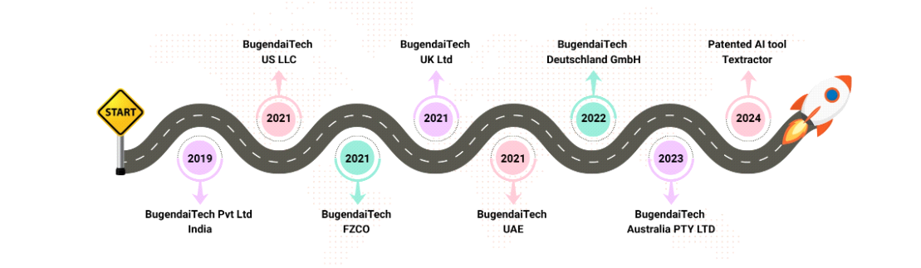

**How it started:**Bugendaitech started as a bold idea: What if businesses—no matter their size—had access to enterprise-grade technology that helped them grow, compete, and innovate? With that question in mind, our team of forward-thinkers, problem-solvers, and tech enthusiasts set out to develop solutions to redefining how businesses operate from small startups to Fortune 500 companies, our solutions have helped organizations in the healthcare, manufacturing, real estate, legal, and oil and gas industries transform their operations.

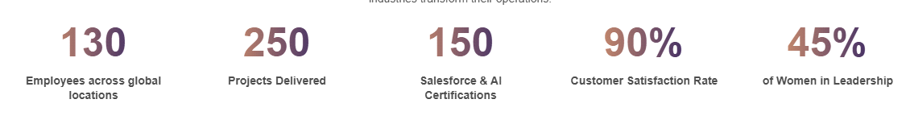

Today, Bugendaitech is more than a technology provider—we are a partner in transformation. Our expertise includes AI, automation, cloud integration, data analytics, and customized digital solutions designed to fit the evolving needs of businesses worldwide.

**Vision and Mission:**

* **Innovation at the Core:**

Technology is evolving, and so are we. From AI-powered automation to next-gen Salesforce solutions, we push boundaries to deliver cutting-edge products like AgentForce and Textractor, redefining efficiency in business operations.

* **Global Presence, Local Impact:**

With a footprint across India, the USA, UAE, the UK, Europe, and Australia, we work seamlessly across time zones, ensuring businesses receive unparalleled support and strategic solutions no matter where they are.

* **Trusted Partner for Growth:**

Success is not just about technology—it is about relationships. We prioritize long-term business partnerships and deliver solutions tailored for scalability, efficiency, and impact.

**At BugendaiTech, we aim to reduce technology gaps and drive sustainable, AI-powered transformation for businesses worldwide. Our mission? To provide scalable, intelligent, and tailored digital solutions that help businesses optimize workflows, enhance productivity, and achieve long-term success.**

**Products:**

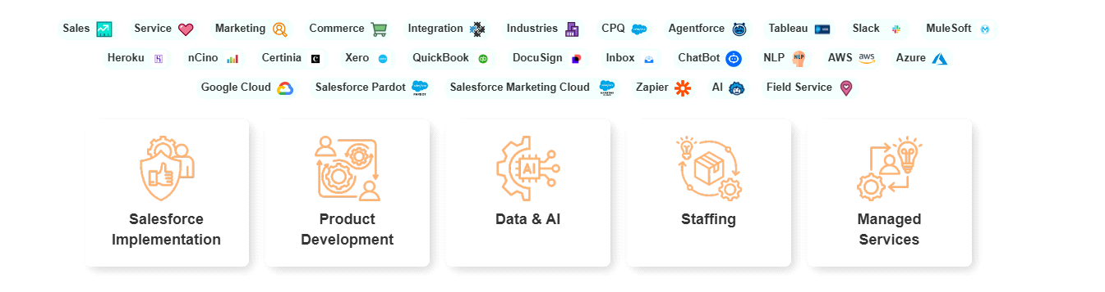

**Partners:**



**Departments worked in/Jobs Performed**

**Department1 /Job 1/ Activity 1:**

## **Department 1: AI and Software Development**

**Job 1:** Internal AI Tool Development  
**Activity 1:** Personalized Learning Explainer (Prototype using Gemini API)

### **1. Introduction**

This project is an early prototype of a personalized learning explainer built using Python and Google’s Gemini 1.5 Flash API. It accepts natural language queries from users and provides age-specific conceptual explanations through a simple Streamlit interface. At this stage, the application was focused only on generating plain-text theoretical responses — with no built-in math solving or code analysis. The project served as an experimental base to understand how generative AI could assist in simplifying educational content.

### **2. Purpose of the Project**

The key objectives of this version were:

* To test how effectively Gemini can explain academic topics in simple terms.
* To explore age-based response tuning using prompt design.
* To build a basic working app for learning conceptual queries with AI help.
* To understand prompt handling and UI setup before adding advanced features.

### **3. Tools and Technologies Used**

| **Tool / Technology** | **Purpose** |
| --- | --- |
| Python | Core programming language |
| Streamlit | Web framework for quick UI development |
| Google Gemini 1.5 Flash | AI model for generating text explanations |
| google.generativeai | Gemini API wrapper |
| Regular Expressions | For basic input filtering and classification |
| IDE: VS Code | Coding and testing |
| Platform | Local desktop/web browser |

### **4. How It Works**

#### a) Frontend (App.py)

* Built using Streamlit.
* Users enter their age and a topic or question.
* Input is filtered to block casual or unsafe messages.
* Prompt is built using age-specific tone guidance and sent to Gemini.
* Response is shown directly in the UI with an option for feedback.

#### b) Prompt Handling (function.py)

* Input is checked for conversational or unsafe words.
* Very basic prompt classification (concept/factual only).
* Age-based rules modify the explanation style using plain English.
* Math and code queries were not handled at this stage.

#### c) API Communication (model_logic.py)

* Sends user input and prompt to Gemini API hosted on localhost.
* Returns generated explanation and handles fallback if response fails.

### **5. Project Structure**

bash

CopyEdit

personalized-learning-gemini/

│

├── App.py # Main Streamlit app

├── function.py # Filtering and prompt logic

├── UI.py # User interface display

├── model_logic.py # Gemini API communication

### **6. Features**

* Explains user queries using natural language
* Age-specific tone selection (child, teen, adult)
* Basic filtering for safety and casual language
* Simple interface with user feedback option
* Uses Gemini API for instant conceptual output

### **7. Advantages**

* Quick and lightweight learning assistant
* Adaptable to various age groups
* Fully functional without external databases or storage
* Local setup using Streamlit — easy to deploy and test
* Helped validate the idea of using AI for personalized learning

### **8. Limitations**

* No math solving or formula support
* No code generation or code explanation
* Responses were sometimes generic due to weak prompts
* No persistent memory or context beyond one query
* Depended entirely on Gemini API response quality

### **9. Future Scope**

* Add support for math solving and geometry explanation
* Introduce code explanation module
* Implement smarter prompt filtering and classification
* Replace Gemini with local LLM like TinyLLaMA via Ollama
* Improve UI design and add topic categories
* Store session history or allow downloadable answers

### **10. Conclusion**

The Gemini-powered prototype was a basic but functional attempt to personalize learning using generative AI. Though limited in scope, it proved that even simple prompt engineering combined with age-based logic can make educational content more relatable. This project formed the basis for the later, more advanced **Ollama-based explainer** with improved accuracy, math solving, and safer filtering built under mentorship.

**Department 2 /Job 2/ Activity 2:**

## **Department 2: AI Integration and Web Development**

**Job 2:** Internal Productivity Tool Development  
**Activity 2:** Personalized Learning Explainer App

### **1. Introduction**

The Personalized Learning Explainer App is an educational tool designed to deliver age-specific, simplified explanations for various academic topics. It uses a locally hosted lightweight language model (via Ollama) to generate explanations, solve math problems, answer factual queries, and provide beginner-friendly code snippets. A safe filtering mechanism ensures the model avoids inappropriate or off-topic responses. The tool is built with a modular architecture using **Streamlit for UI**, **Flask-style backend logic**, and **guardrails** for safety.

### **2. Purpose of the Project**

The main objectives of this project are:

* To offer simplified and accurate educational content tailored to the learner’s age.
* To utilize local models via Ollama for privacy-friendly, offline usage.
* To automatically detect prompt types (conceptual, factual, math, code) and respond accordingly.
* To filter out irrelevant or unsafe queries using keyword-based validation.

### **3. Tools and Technologies Used**

| **Tool / Technology** | **Purpose** |
| --- | --- |
| Python | Core programming language |
| Streamlit | Web interface for user interaction |
| Ollama | Runs local LLM (e.g., gemma:2b, mistral) |
| Requests | API communication with the local model |
| Regular Expressions | Prompt classification and content filtering |
| SymPy | Evaluates advanced math expressions |
| Custom Filters | Guards against conversational and unsafe inputs |

### **4. How It Works**

#### a) Frontend (App.py)

* Developed using Streamlit.
* Collects user age and query.
* Filters unsafe or casual inputs.
* Classifies the prompt type: concept, math, factual, or code.
* Displays AI-generated explanations with user feedback options.

#### b) UI Module (UI.py)

* Handles UI setup: header, inputs, sliders, and layout.
* Formats and displays results with styled HTML blocks.
* Shows side instructions and manages feedback interaction.

#### c) Function Module (function.py)

* Detects and blocks casual or unsafe inputs using keyword filters.
* Classifies queries using regular expressions.
* Solves basic and advanced math expressions with clean step-by-step outputs.
* Tailors prompts based on user’s age for more relatable responses.

#### d) Backend Logic (model_logic.py)

* Selects the desired Ollama model.
* Sends prompts to the model running on localhost:11434.
* Retrieves and returns the AI-generated explanation to the frontend.

### **5. Features**

* Personalized explanations based on user age.
* Math solver for basic geometry and advanced expressions.
* Factual and conceptual answers with a clear tone.
* Beginner-friendly code generation.
* Content safety using conversational and banned keyword filters.
* Local model support with selectable LLMs (e.g., Gemma, Mistral).
* User feedback handling and real-time improvements.

### **6. Advantages**

* **Runs Locally:** No internet dependency; ensures data privacy.
* **Fast & Lightweight:** Quick model response using Tiny models like gemma:2b.
* **Age-Adapted Explanations:** Helps both children and adult learners.
* **Safe for Learning:** Prevents unsafe or casual content generation.
* **Modular Codebase:** Easy to update or extend individual parts.

### **7. Limitations**

* No persistent storage (session resets on page refresh).
* Keyword filtering is rule-based, not context-aware.
* Image, voice, or video features are not yet supported.
* Doesn't use stateful memory beyond the current session.

### **8. Future Scope**

* Add support for image-based explanations (e.g., diagrams).
* Include voice input and output for better accessibility.
* Implement persistent storage or login-based session history.
* Improve safety filters using small context-aware classifiers.
* Expand model choices for advanced users.
* Mobile-friendly design with responsive layout enhancements.

### **9. Conclusion**

This Personalized Learning Explainer App combines simplicity, safety, and local AI power to make learning easier and more accessible for all age groups. It demonstrates how small language models can be meaningfully integrated into educational tools — ensuring responsible, personalized AI use in real-world applications.

## **Learnings from Internship**

**(5th June 2025 – 5th July 2025)**

Before diving into specific project tasks, we were first guided through a series of practical training sessions. These early weeks helped us get comfortable with the tools and technologies we’d be using. More importantly, they gave us a clear idea of how things work outside of textbooks and into actual development work.

### **1. Python Programming (Refresher & Real Use)**

* Revisited all the basics — from variables and loops to if-else and functions.
* Worked with core data structures like lists, dictionaries, and sets.
* Focused on writing small, testable code blocks before applying them to larger applications.
* This made it easier later when I started working with backend logic in the learning explainer tool.

### **2. SQLite Basics**

* Got familiar with how SQLite works as a lightweight database.
* Understood the idea of creating tables, storing rows, and writing basic queries.
* Though I didn’t build a complete database into my app, it gave me a solid understanding of how data is stored and accessed.
* Also explored how this can be integrated into Python using the sqlite3 module.

### **3. Connecting SQL with Python (Concept Only)**

* Learned how Python interacts with SQLite using sqlite3.
* Looked at examples where SQL queries are triggered from Python code.
* Explored how parameterized queries help make data operations more secure.
* While I didn’t build a data-heavy tool, this helped me understand how real applications handle user data.

### **4. Regular Expressions (Practical Filtering)**

* Spent time understanding how pattern matching works with regex in Python.
* Used it mainly to filter and clean user input in the app I built.
* Applied it to block unsafe or unnecessary queries before sending them to the AI model.
* This made me realize how small things like input checks can make apps safer and cleaner.

### **5. Prompt Engineering**

* Learned how to design prompts that actually guide the AI to give better responses.
* Tried different styles — like factual, math-related, and concept-based prompts.
* Also worked on adjusting the tone based on the user’s age (e.g. simpler for kids, detailed for older users).
* This was directly applied in the learning explainer project, especially when I moved from Gemini to Ollama.

### **6. Communication & Team Skills**

* Got used to sending daily updates and asking for feedback clearly and professionally.
* Learned how to approach mentors with doubts and respect time and tone.
* Understood how important teamwork, timing, and transparency are in a professional setup.
* These soft skills helped a lot while working under guidance in the second half of the internship.

**Analysis/Report  
  
  
  
Project 1: Personalized Learning Explainer AI using Gemini API**  
• Successfully developed an interactive learning app using Streamlit and Google’s Gemini Pro API.  
• Accurately generated age-specific explanations for user queries in areas like general concepts, basic math, and code.  
• GUI built using Streamlit was clean, responsive, and intuitive for learners across age groups.  
• Prompt handling included conversational filters, safety checks for empty input, and custom prompt formatting.  
• Gemini API integrated via google.generativeai, returning quick and precise content.  
• Error handling within the model logic provided stability even when the API failed to respond.  
• Modular design split across App.py, function.py, model_logic.py, and UI.py, enabling easy debugging and scalability.  
• Focused on enhancing educational experience using AI — effective for learners with limited subject background.  
• Showcased real-world application of generative AI in education and intelligent tutoring systems.  
  
  
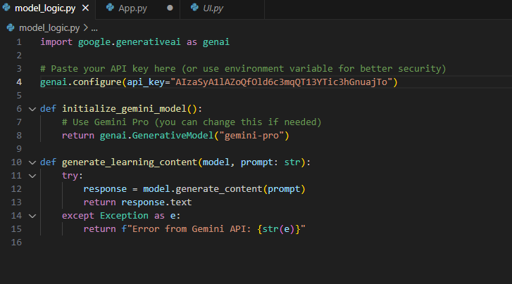

## **Project: Personalized Learning Explainer**

This project is a Streamlit-based educational assistant that generates age-specific explanations using **Gemma:2b** and **Mistral** models via **Ollama**. Users input their age and a query, and the system tailors the response based on query type — such as concept, factual, math, or code.

It features:

* **Model selection** (Gemma or Mistral) from the sidebar
* **Prompt classification and filtering** using custom logic and regex
* **Safe prompt handling** with a banned keyword list
* **Age-adjusted explanations** for personalized learning
* **Offline AI responses** by running LLMs locally through localhost:11434
* **Interactive feedback** for refining the AI’s output

The project demonstrates how local AI models, UI design, and responsible content handling can work together to build a smart, safe learning tool.

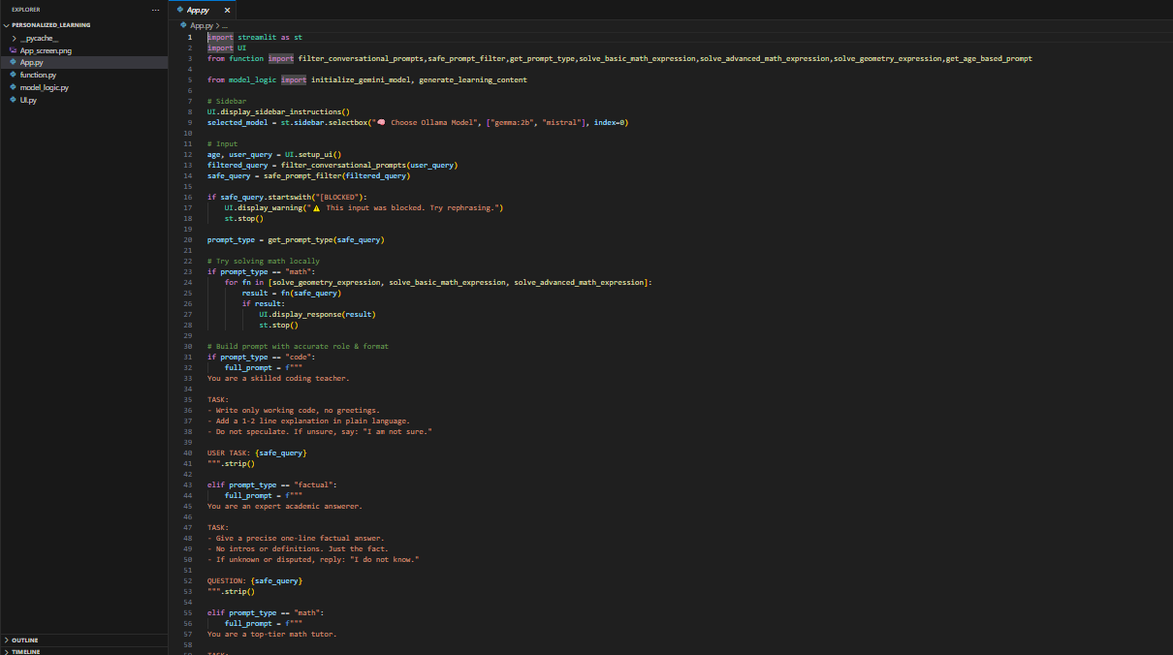

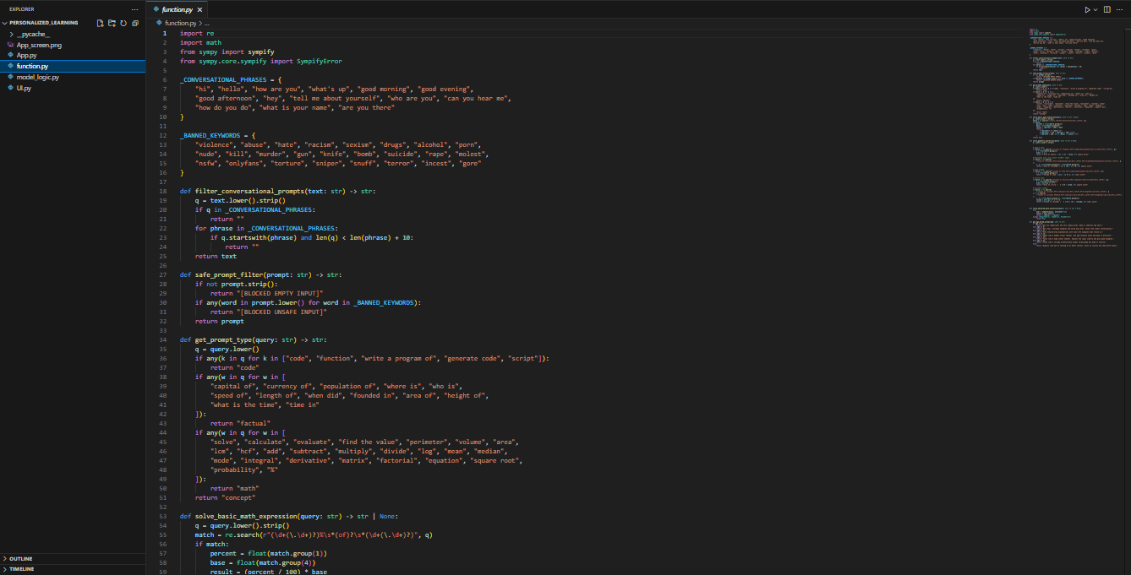  
  
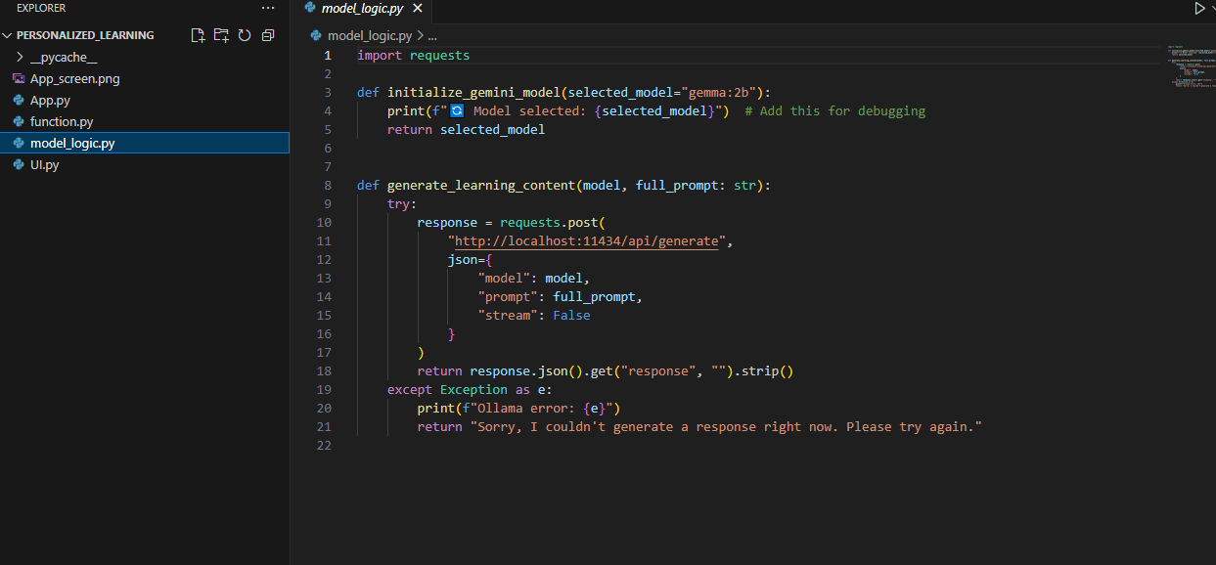

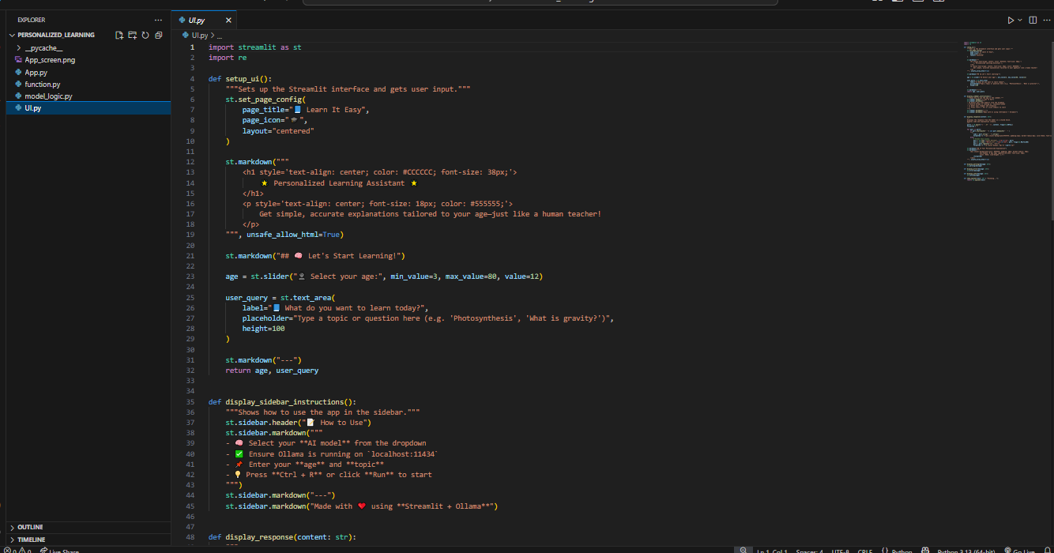

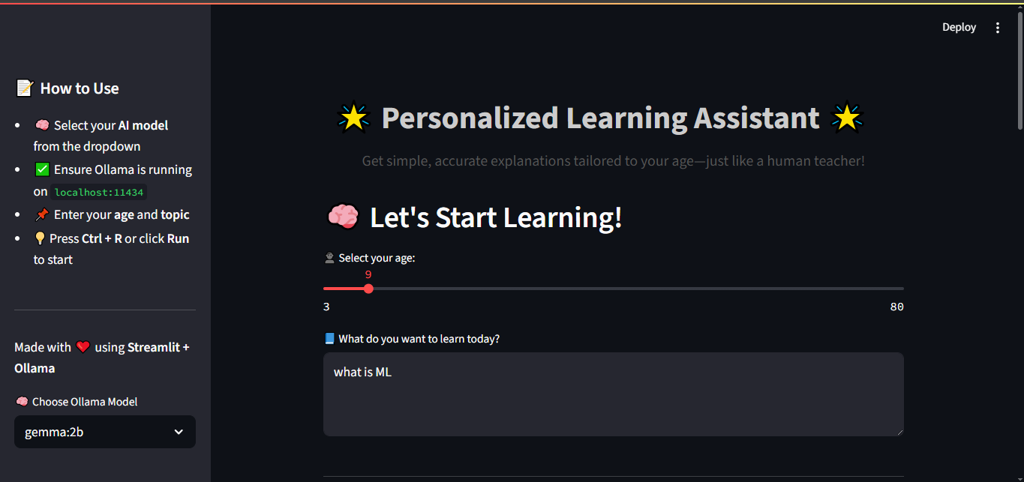

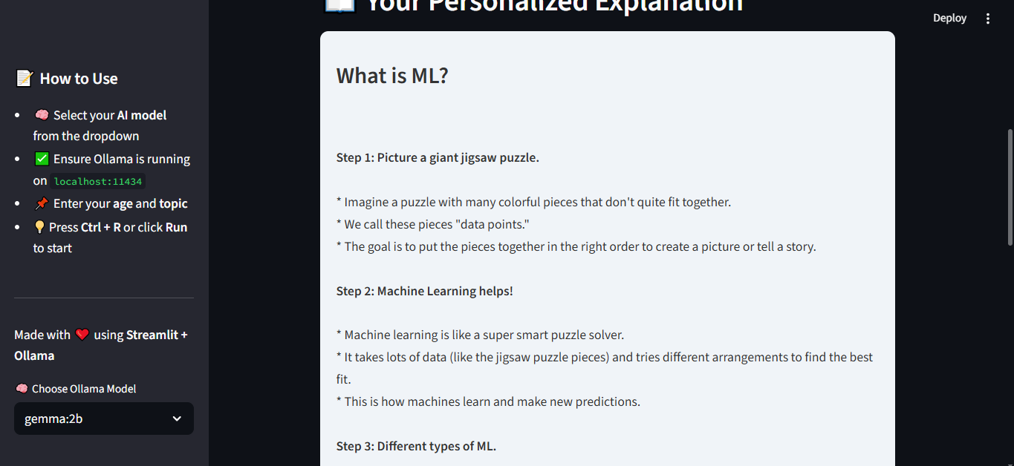  
  
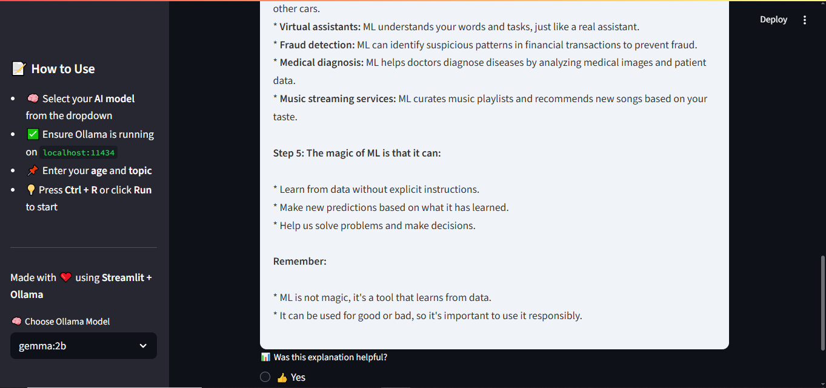

**Observations and Challenges**

**Observations:**

* Understood how corporate work culture functions in real-time settings.
* Learned the importance of professional communication through daily email updates and follow-up messages.
* Experienced the need for regular team collaboration during meetings and discussions.
* Got comfortable with tools and habits used in the industry, such as:
  + Attending daily meetings to stay aligned with goals.
  + Completing daily assigned tasks within deadlines.
  + Practicing teamwork and coordination to meet project objectives.
* Realized how writing daily emails and tracking progress improved my own accountability and consistency.

**Challenges:**

* Faced code-related issues during both projects, which required debugging and problem-solving.
* In the Code Explainer project, there were limitations related to API key usage such as token limits and response delays.
* In the AI Storyteller project, encountered difficulties implementing the Guardrails module, especially in filtering and validating AI responses.
* Sometimes struggled with error handling and edge cases while integrating AI responses into the application.
* Had to research and self-learn new tool (like Ollama) to complete the projects efficiently.
* Balancing daily reporting and technical work was initially overwhelming, but it helped me become more organized.

**Conclusion**

My internship experience at BugendaiTech was truly enriching and insightful. I am deeply grateful to my mentors and the entire team for their constant guidance, support, and encouragement. The mentors were not only knowledgeable and smart but also approachable and genuinely helpful, making the experience smooth and meaningful. The internship started with thorough training sessions that walked us through the necessary tools and concepts, preparing us well before we began working on actual projects. This structured approach helped me understand how professional workflows operate and the importance of collaboration in a corporate environment. I had the opportunity to explore and work with new tools like, Streamlit, Ollama, Guardrails, and Regex, which significantly enhanced my technical skills. The experience of writing daily emails, attending regular meetings, completing assigned tasks, and tracking progress made me more organized, disciplined, and aware of workplace dynamics. I also faced challenges like API key limits and errors while coding, especially with Guardrails, but overcoming them taught me the importance of debugging, problem-solving, and persistence. In addition to project work, the guest lectures we attended were insightful, giving us exposure to various fields and career possibilities. Overall, this internship helped me understand how things actually work in a professional setting and gave me hands-on experience in both technical work and team collaboration. It was a very positive and valuable experience that has contributed significantly to my growth.



